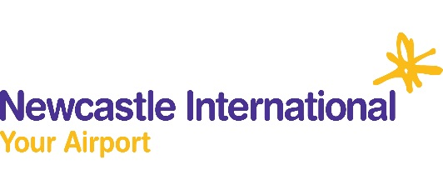
Newcastle International Airport
Summer Opening Hours
 | Monday | Tuesday | Wednesday | Thursday | Friday | Saturday | Sunday
Bar 11 | 4.30am – 8.30pm | 4am – 7.30pm | 4am – 8.00pm | 3.30am – 7.30pm | 3.30am – 7.30pm | 4am – 4.30pm | 3.30am – 8.30pm
Beer House | First - last flight | First - last flight | First - last flight | First - last flight | First - last flight | First - last flight | First - last flight
Boots | 4am – 9.30pm | 4am – 8.30pm | 4am –9pm | 3.30am – 9.30pm | 3.30am – 8pm | 4am -6.30pm | 3.30am –Last Flight
Burger King | 4.30am – 9pm | 5am – 7pm | 5am - 7pm | 5am – 6.30pm | 5am - 7pm | 5am – 4pm | 4.30am - 6pm
Cabin Bar | 4.30am - 7pm | 4.30am - 8pm | 4.30am - 8pm | 4.30am – 7pm | 4.30am – 7pm | 4.30am – 4.30pm | 4.30am – 5pm
Café Ritazza | 4am – 7.30pm | 3.30am – 7.30pm | 3.30am – 7.30pm | 3.30am - 8pm | 3.30am - 8pm | 3.30am - 5pm | 3.30am - 8pm
QuayStone | 3.30am – 8pm | 3.30am – 8.30pm | 4am – 8.30pm | 3.30am – 8.30pm | 3am – 8pm | 3.30am - 7pm | 3.30am – 7.30pm
Naked Deli | 5am – 7pm | 5am – 7pm | 5am – 7pm | 5am – 7pm | 5am –7pm | 5am – 5pm | 5am – 7pm
Pitta & Brew | 5am – 7pm | 5am – 7pm | 5am – 7pm | 5am – 7pm | 5am – 7pm | 5am – 5.30pm | 5am – 6.30pm
Upper Crust | 4.30am - 7pm | 4.30am - 7pm | 4.30am - 7pm | 4.30am - 7pm | 4.30am - 7pm | 4.30am – 3.30pm | 4.30am –7pm
WHSmiths | First - last flight | First - last flight | First - last flight | First - last flight | First - last flight | First - last flight | First - last flight
World Duty Free | First - last flight | First - last flight | First - last flight | First - last flight | First - last flight | First - last flight | First - last flight

*Timetable may be subject to change depending on flight schedules

